LAB4_3

setwd(".")  
library(knitr)  
library(ggplot2)  
germinacion<-read.table("Archivos/germination.csv", header=T, sep=",")  
attach(germinacion)

#APARTADO A

n_germinadas<- sample - count  
p_n_germinadas<- 100*(n_germinadas/sample)  
germinacion<-cbind(germinacion,n_germinadas,p_n_germinadas)  
attach(germinacion)

## The following objects are masked _by_ .GlobalEnv:  
##   
## n_germinadas, p_n_germinadas

## The following objects are masked from germinacion (pos = 3):  
##   
## count, extract, Orobanche, sample

kable(germinacion[1:10,])

|  |  |  |  |  |  |
| --- | --- | --- | --- | --- | --- |
| count | sample | Orobanche | extract | n_germinadas | p_n_germinadas |
| 10 | 39 | a75 | judia | 29 | 74.35897 |
| 23 | 62 | a75 | judia | 39 | 62.90323 |
| 23 | 81 | a75 | judia | 58 | 71.60494 |
| 26 | 51 | a75 | judia | 25 | 49.01961 |
| 17 | 39 | a75 | judia | 22 | 56.41026 |
| 5 | 6 | a75 | pepino | 1 | 16.66667 |
| 53 | 74 | a75 | pepino | 21 | 28.37838 |
| 55 | 72 | a75 | pepino | 17 | 23.61111 |
| 32 | 51 | a75 | pepino | 19 | 37.25490 |
| 46 | 79 | a75 | pepino | 33 | 41.77215 |

#APARTADO B

medias_n_g<-aggregate(p_n_germinadas~Orobanche+extract, germinacion, mean)  
kable(medias_n_g)

|  |  |  |
| --- | --- | --- |
| Orobanche | extract | p_n_germinadas |
| a73 | judia | 67.39683 |
| a75 | judia | 62.85940 |
| a73 | pepino | 53.14784 |
| a75 | pepino | 28.46002 |

boxplot(p_n_germinadas~Orobanche+extract,col="green")  
  
#A73 judia  
abline(h = medias_n_g[1,3], col="red", lwd="2")  
  
#A75 judia  
abline(h = medias_n_g[2,3], col="red", lwd="2")  
  
#A73 pepino  
abline(h = medias_n_g[3,3], col="red", lwd="2")  
  
#A75 pepino  
abline(h = medias_n_g[4,3], col="red", lwd="2")  
grid()

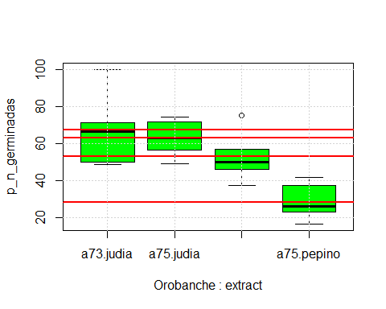 #APARTADO C

#Judias  
boxplot(p_n_germinadas[extract=="judia"]~Orobanche[extract=="judia"],   
 col="lightblue", ylim=c(0,100), xlab="genotipo")  
  
modelo1<-lm(p_n_germinadas[extract=="judia"]~Orobanche[extract=="judia"])  
abline(modelo1, col="blue", lwd=3)  
text(1.5,50,labels="judia")  
grid()  
  
#Pepinos  
boxplot(p_n_germinadas[extract=="pepino"]~Orobanche[extract=="pepino"],   
 col="orange", ylim=c(0,100), xlab="genotipo", add=T)  
modelo1<-lm(p_n_germinadas[extract=="pepino"]~Orobanche[extract=="pepino"])  
abline(modelo1, col="brown", lwd=3)  
text(1,20,labels="pepino")

